Exercise Answers Chapter 13

Question 2

- The appropriate sections of the computer output generated from a Mac JMP™ session is incorporated within the answer to these questions. Other statistical packages would generate similar tables but with much different formats.

Using the full dataset of 53 lakes the following results are obtained for the simple regressions between Mercury and the four independent variables:

Alkalinity (Alk)

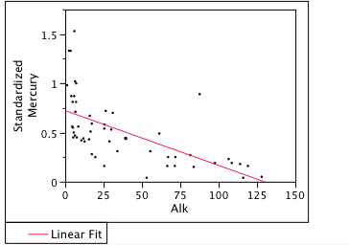

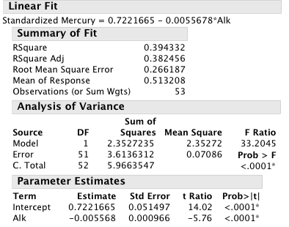

pH (pH)

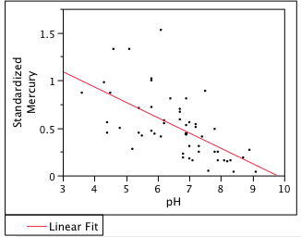

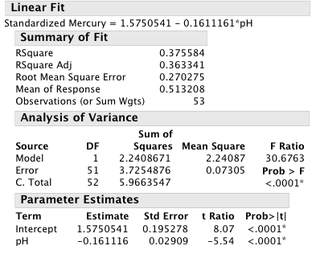

Calcium (CA)

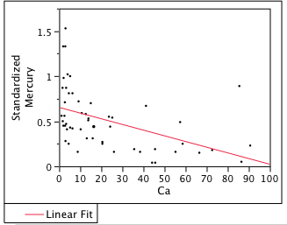

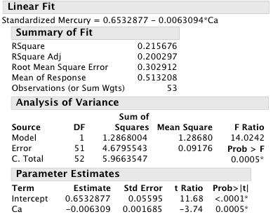

Chlorophyll

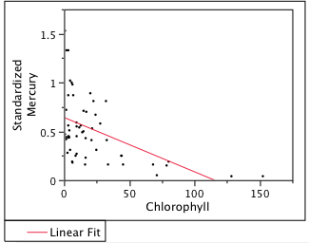

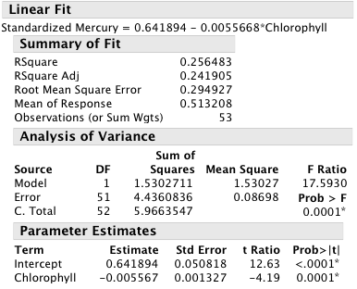

From this output it is clear that all four independent variables are negatively associated with Mercury, though Alkalinity has the best fit. Moreover, it is easily seen that transformations are needed. Notice in the Alkalinity regression that a nonlinear function asymptotic to the Y-axis would provide a superior fit to a simple linear regression.

- Let us consider the results for the Alkalinity variable. Following the pattern (c) in Figure 13-10, we see that an appropriate action might be a logarithmic transformation. This is confirmed in the following output:

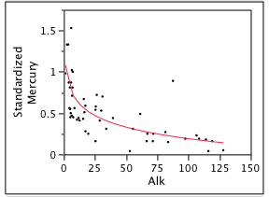

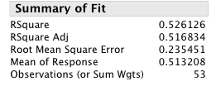

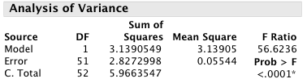

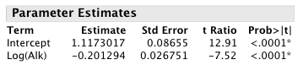

In comparison to the original untransformed version of the equation, we note several improvements. First, the scattergram and graph of the equation appears to follow the path of the mean levels of mercury more closely than the linear model. Note also that the graph has been drawn using Alkalinity in its actual units, not the transformed ones. We clearly see that the regression relationship is truly nonlinear. Note the increase in the value of R², from 0.394 in the linear model to a value of 0.526 in the transformed model. The F-ratio of the overall equation is higher for the same degrees of freedom, indicating that the results of the equation are less likely due to mere chance.

If we were to fit a fully multiplicative model of the form

using the double-logarithmic transformation inherent in equation 13-10, the results reveal even greater improvement. First, we note the shape of the model seems to better predict the mercury levels in low alkalinity lakes. By comparing the graphs of the double-log model to the model where only alkalinity is transformed, this is readily apparent.

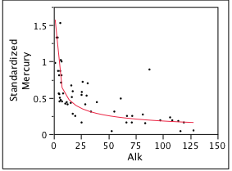

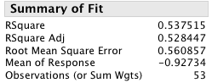

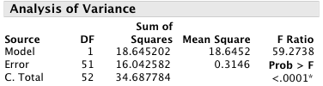

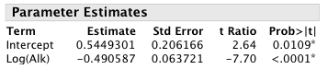

- The results for the all possible regressions in which no transformations are undertaken on any of the variables are summarized in the following table:

Model | No. of Independents | Variables Included | R²
1 | 1 | Alkalinity | 0.39
2 | 1 | pH | 0.38
3 | 1 | Ca | 0.22
4 | 1 | Chlorophyll | 0.26
5 | 2 | Alkalinity  Ca | 0.45
6 | 2 | Alkalinity  pH | 0.41
7 | 2 | Alkalinity  Chlorophyll | 0.45
8 | 2 | pH  Ca | 0.39
9 | 2 | pH  Chlorophyll | 0.40
10 | 2 | Ca  Chlorophyll | 0.34
11 | 3 | Alkalinity  pH  Ca | 0.46
12 | 3 | Alkalinity  pH  Chlorophyll | 0.47
13 | 3 | Alkalinity  Ca  Chlorophyll | 0.46
14 | 3 | pH  Ca  Chlorophyll | 0.42
15 | 4 | Alkalinity  pH  Ca  Chlorophyll | 0.48

The graph of this data reveals the same structure as Figure 13-3. The impact of the successive addition of new variables begins to diminish. It should be noted though that these results use the simple regression formulation of the equation which has been show to be inferior to a logarithmic model.

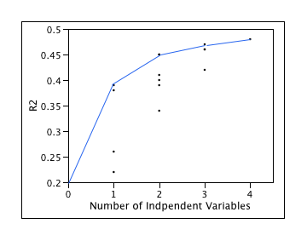

- a. and c.

The following output summarizes the three models:

Holdout sample of 27 lakes (Table 13.6)

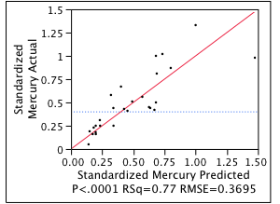

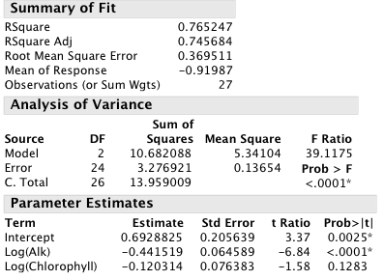

Base Data 26 lakes

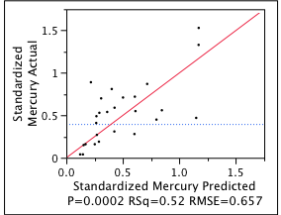

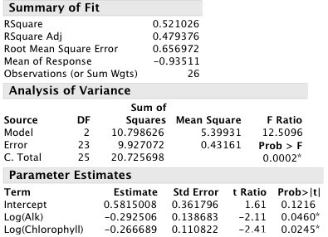

Complete Data 53 lakes

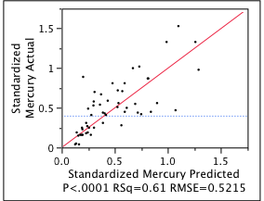

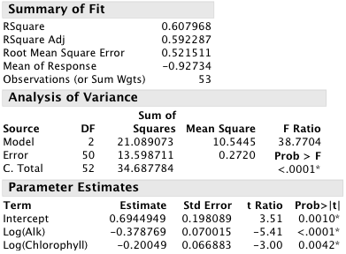

There are several things worth comparing. First, note that the two sub-samples do not have similar results. The values differ significantly with the first subsample providing a remarkably better fit (0.765 vs. 0.521) with the complete sample revealing an intermediate value of 0.608.

In the first regression, only the intercept and log alkalinity are statistically significant at $α=0\text{.}\text{05}$ while in the holdout sample the variables alkalinity and chlorophyll are significant but not the intercept. The regression of the complete sample indicates all three variables are significant. Besides the level of significance, note apparent differences in the value of the coefficient for each variable: The alkalinity coefficient varies from
-0.29 to -0.44 and the chlorophyll coefficient ranges from -0.12 to -0.27.

What does this tell us? Well these two samples are considerably different. Since they were created by taking every other lake from an alphabetical ordering of the lakes, this is not surprising. Whenever the data is split into two parts, some consideration should be given to ensuring that the two samples have equivalent distributions of the independent variables. The following table summarizes some simple descriptive statistics for these two samples:

 | 27 Lake Sample | 26 Lake Sample
Alkalinity
Mean | 39.24 | 35.75
Std. Dev | 42.52 | 33.90
Min | 1.20 | 2.50
Max | 128.00 | 116.00
Chlorophyll
Mean | 19.56 | 26.81
Std. Dev | 20.18 | 39.04
Min | 1.60 | 0.70
Max | 80.10 | 152.40

There are a few differences of note. First, the mean level of chlorophyll in the holdout sample is about one-third higher than the first sample (26.81 vs. 19.56) but is also almost twice as variable. The holdout sample also includes a lake with almost twice the chlorophyll as the maximum value in the first 27 lake sample (152.40 vs. 80.10). This lake may be an outlier and be quite influential in explaining the differences between the two equations.

b) The following tables use the equation from the holdout sample of 27 lakes

$$\text{Std}\text{.} \text{Mercury}=\text{.}\text{693}∗{\text{Alkalinity}}^{−0\text{.}\text{442}}∗{\text{Chlorophyll}}^{−0\text{.}\text{120}}$$

and works in the original units of the equation. First, we use this multiplicative form to predict standardized Mercury.

Name | Alkalinity | Chlorophyll | Standardized Mercury | Pred from 27 lake equation | Squared Error
Alligator | 5.9 | 0.7 | 1.53 | 0.330 | 1.440
Apopka | 116 | 128.3 | 0.04 | 0.047 | 0.000
Brick | 2.5 | 1.8 | 1.33 | 0.431 | 0.809
Cherry | 5.2 | 3.4 | 0.45 | 0.289 | 0.026
Deer Point | 26.4 | 1.6 | 0.72 | 0.154 | 0.320
Dorr | 6.6 | 14.9 | 0.71 | 0.218 | 0.242
Eaton | 25.4 | 11.6 | 0.54 | 0.124 | 0.173
George | 83.7 | 78.6 | 0.15 | 0.058 | 0.008
Harney | 61.3 | 13.9 | 0.49 | 0.082 | 0.167
Hatchineha | 31 | 17 | 0.7 | 0.108 | 0.350
Istokpoga | 17.3 | 9.5 | 0.59 | 0.150 | 0.194
Josephine | 7 | 32.1 | 0.81 | 0.193 | 0.380
Kissimmee | 30 | 21.5 | 0.53 | 0.107 | 0.179
Louisa | 3.9 | 7 | 0.87 | 0.301 | 0.324
Minneola | 6.3 | 0.7 | 0.47 | 0.321 | 0.022
Newmans | 28.8 | 32.7 | 0.41 | 0.103 | 0.094
Ocheese Pond | 4.5 | 3.2 | 0.56 | 0.310 | 0.062
Orange | 25.4 | 45.2 | 0.16 | 0.105 | 0.003
Parker | 53 | 152.4 | 0.04 | 0.066 | 0.001
Puzzle | 87.6 | 20.1 | 0.89 | 0.067 | 0.677
Rousseau | 97.5 | 6.2 | 0.19 | 0.074 | 0.014
Shipp | 66.5 | 68.2 | 0.16 | 0.065 | 0.009
Tarpon | 5 | 9.6 | 0.55 | 0.259 | 0.084
Trafford | 81.5 | 9.6 | 0.27 | 0.076 | 0.038
Tsala Apopka | 34 | 4.6 | 0.31 | 0.121 | 0.036
Wildcat | 17.3 | 2.6 | 0.28 | 0.175 | 0.011
 |  |  |  | MSPR | 0.218

For Alligator lake, for example

$$\begin{aligned}\text{Std}\text{.} \text{Mercury}=\text{.}\text{693}∗{\text{Alkalinity}}^{−0\text{.}\text{442}}∗{\text{Chlorophyll}}^{−0\text{.}\text{120}} \\ \text{Std}\text{.} \text{Mercury}=\text{.}\text{693}∗5\text{.}9^{−0\text{.}\text{442}}∗0\text{.}7^{−0\text{.}\text{120}}=0\text{.}\text{330}\end{aligned}$$

This is a relatively poor prediction for this lake which has an extremely high level of mercury. Not surprisingly, the mean square prediction error for the lakes as a whole is relatively poor.

