Exercise Answers, Chapter 15

- Using the Keokuk dataset, graph annual discharge as a time series. Do you think the sample lag-1 autocorrelation (r₁) is positive or negative? (Hint: what would a scatterplot of y_{t} vs. y_{t+1} show?) Compute r₁. Does its value confirm your suspicions?

Solution:

Plotting the discharge in one year against the previous year, we get:
The lag-1 autocorrelation is 0.42.
- Given the following time series of 100 values:

–0.7784 0.7500 –0.3678 –0.5595 –0.8068 0.6306 –0.2161 –0.5251
0.0090 0.3766 –0.3266 –0.2225 0.5015 0.1136 –0.3976 0.0820
0.2030 0.2598 –0.1462 0.3907 –0.0836 0.4817 –0.0666 0.4311
–0.0005 0.4766 –0.4059 –0.2351 –0.1060 0.1564 –0.6055 –0.1502
–0.4424 0.1580 0.0465 –0.6030 –0.2929 0.0327 0.0628 –1.2191
–0.4335 –0.4555 0.1592 –1.2033 –0.1421 –0.4881 0.6016 –1.2358
–0.0693 –0.3998 0.6816 –1.0855 –0.2658 –0.3522 0.4368 –0.1493
0.1064 –0.2848 0.6976 –0.1703 0.2378 –0.3518 0.6744 –0.5485
0.2665 –0.7421 0.5483 –0.3396 0.3229 –0.5831 0.1049 –0.7798
0.4224 –0.5528 –0.0297 –0.7729 0.1245 –0.9545 0.1793 –0.3034
0.0054 0.5092 0.2993 0.0193 0.2788 –0.6221 0.4148 0.5104
0.5560 –0.9757 0.4210 0.7366 0.2686 –0.3631 0.5365 0.4295
0.4316 –0.4213 –0.1576 0.2863

- Compute autocorrelations and partial autocorrelations out to lag 15.

Solution:

Lag | AutoCorrelation | Partial Autocorrelation
1 | -0.2736 | -0.2736
2 | 0.2293 | 0.1670
3 | -0.2370 | -0.1546
4 | 0.7008 | 0.6612
5 | -0.2629 | 0.0069
6 | 0.2158 | 0.0042
7 | -0.2629 | -0.1176
8 | 0.4632 | -0.0981
9 | -0.2156 | 0.0327
10 | 0.1811 | -0.0061
11 | -0.2988 | -0.0935
12 | 0.3334 | 0.0076
13 | -0.2030 | -0.0454
14 | 0.1452 | -0.0194
15 | -0.3215 | -0.0834

- Plot the sample autocorrelation and partial autocorrelation functions.

Solution:
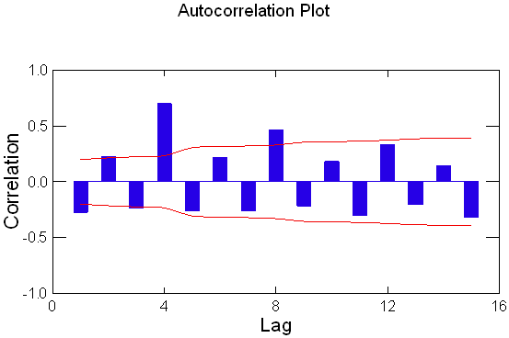

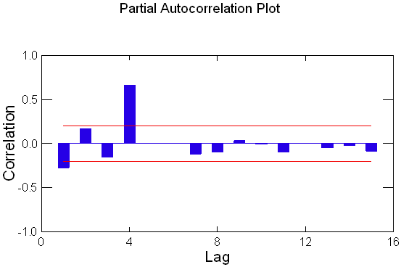

- Graph the amplitude response function for a 5-point running mean with coefficients [0.1, 0.2, 0.4, 0.2, 0.1].

Solution:

This is a symmetric filter with c₋₂ = c₂ and c₋₁ = c₁, thus Equation 15-10 simplifies to

R(f) = 0.4 + (2) 0.2 cos(2πf) + (2) 0.1 cos(4πf)

A graph of this function is shown below:

- Construct a 21-point Lanczos filter with a cutoff frequency of 0.2.
Solution:

k | b_{k} | c_{k}
0 | 0.40000 | 0.40129
1 | 0.29863 | 0.29959
2 | 0.08854 | 0.08883
3 | -0.05501 | -0.05519
4 | -0.06026 | -0.06046
5 | 0.00000 | 0.00000
6 | 0.02914 | 0.02924
7 | 0.01216 | 0.01220
8 | -0.00774 | -0.00776
9 | -0.00707 | -0.00710
10 | 0.00000 | 0.00000

- Graph the amplitude response function of the above. What is the response at f = 0.1?

Solution:

The response at f = 0.1 cycles per observation is R(0.1) = 1.0017

