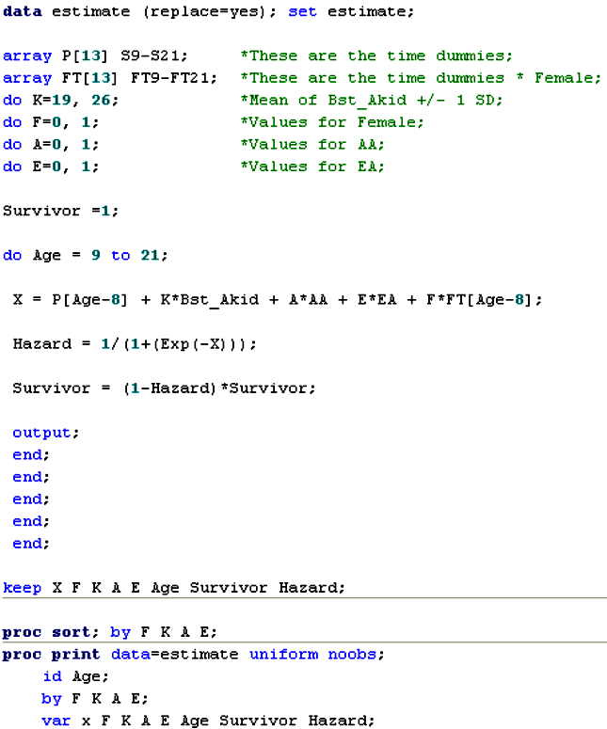
Sample SAS code for creating fitted prototypical plots of the final fitted model 5.

